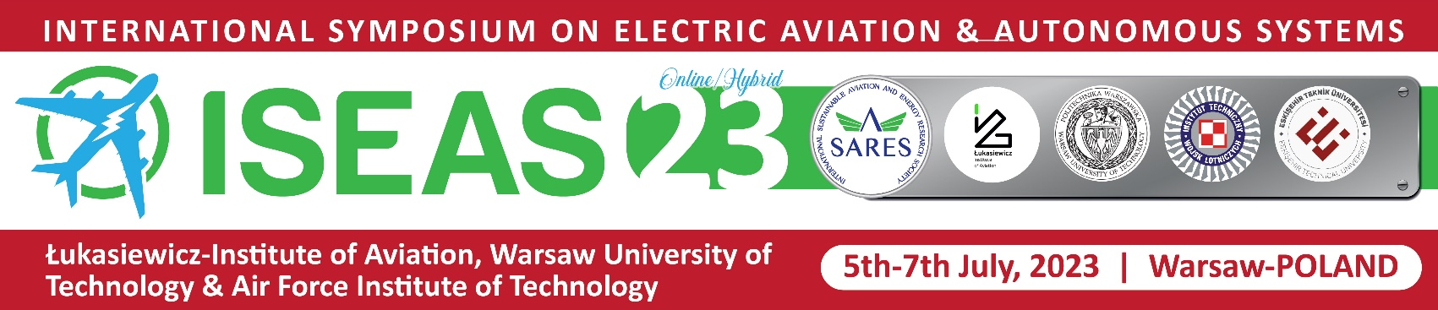

INFORMATION LETTER – FIRST ANNOUNCEMENT

International Symposium on Electric Aircraft and Autonomous Systems (ISEAS-23)
5-7 July 2023

Warsaw

The Lukasiewicz Research Network - Institute of Aviation, the Warsaw University of Technology and Air Force Institute of Technology are organizing the International Symposium on Electric Aircraft and Autonomous Systems (ISEAS-23) on 5-7 of July 2023 in collaboration with the International Sustainable Aviation and Energy Research Society (SARES: https://www.sares.org/).
ISEAS is a multi-disciplinary symposium which aims to address current issues in the field of aviation, such as the electrification of aerial vehicles, all-electric aircraft, and electric energy generation and storage in aerial vehicles.
ISEAS-23 will be organized in traditional partnership with the IX International Scientific-Technical Conference - «Problems of Chemmotology. Theory and Practice of Rational Use of Traditional and Alternative Fuels & Lubricants» - in Kyiv, Ukraine, to cover topics of mutual interest on alternative fuels for the aviation sector.

Symposium Topics
- Electric General Aviation
- More Electric Aircraft
- Hybrid Electric Aircraft
- Electric Aircraft Systems
- Safe and Reliable Electric Power
- Electric in Space
- Unmanned Systems
- On Board Electric Generation and Distribution
- Electric Energy Storage
- Ground Support Equipment
- Electric in Airline Operation
- Electric in Airport Operation
- Chargers and Battery Management Systems
- Serial/Parallel/Light Hybrid Electrical Systems for Aircraft
- Hydrogen Fuel Cells for Aviation
- Electrical Machines for Aircraft Propulsion
- Specific Electrical Air Conditioning and Heating Systems for Aircraft
- Environmental/Cost Efficiency, Energy Savings Algorithms
- Hydrogen Fuels
- Sustainable Alternative Fuels and Lubricants

The ISEAS-23 features keynote presentations by invited speakers and general papers presented in oral sessions (including live e-presentations) and poster sessions. All papers will be peer-reviewed and the accepted papers will appear in the ISEAS-23 Symposium Proceedings. The registered and presented papers will be published by Springer Nature and high-quality papers will be submitted to one of the journals:
- International Journal of Sustainable Aviation (ISSN: 2050-0475, Inderscience);
- International Journal of Aviation Science and Technology (ISSN: 2687-525X, DergiPark Academic);
- Transactions on Aerospace Research (ISSN: 2545-2835, Institute of Aviation, Warsaw).

Please note that this symposium will be held in a hybrid format (face to face and online). Feel free to send abstracts of papers for ISEAS-23. You have the possibility to submit abstracts of papers and find more details on the symposium agenda via the ISEAS-23 website: http://2023.iseasci.org/.
After accepting the abstracts - please send your finished papers and presentations.
Participation in the symposium is payable.

Contact person:
Professor Oleksandr ZAPOROZHETS
Oleksandr.Zaporozhets@ilot.lukasiewicz.gov.pl

